**COMPUTER SCIENCE DEPARTMENT**

Computer Organization and Assembly Language

**Lab Task # 12**

**Last date of Submission: 26th May 2024**

# Submitted To: Sir Ahmed Saleem

**Student Name: UBAID-BIN-WARIS**

# Reg. Number: 2212416

# 

**Question no. 01**

Consider an array containing 10 numbers. You can declare the array as:  num_array db 22d, 15d, 24d, 49d, 33d, 23d, 13d, 74d, 47d, 60d        
Find and display the greatest number in the array?

**Code**

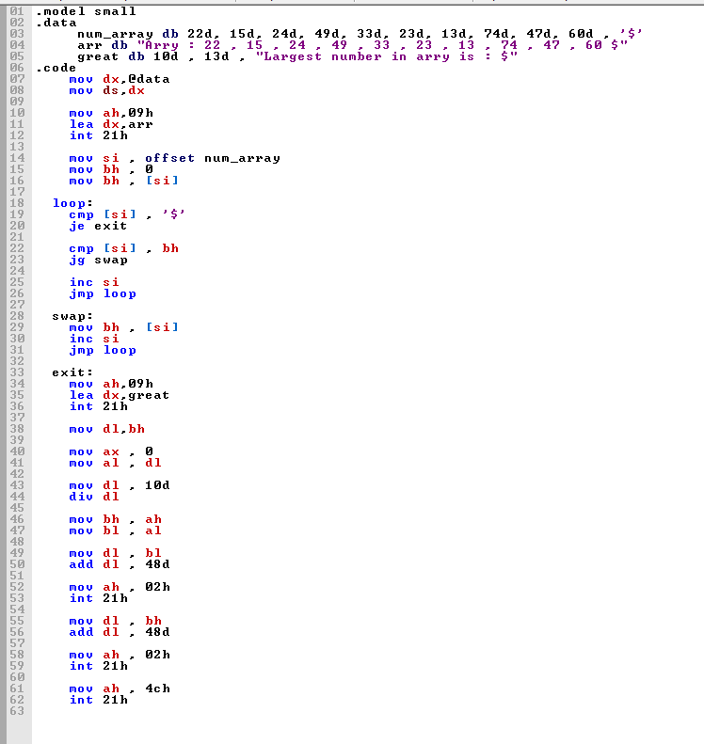

**Output**

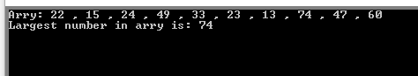

**Question no. 02**

Write a program to search a given word (string) in a given text/sentence (another string). For example, the program searches the word ‘fox’ in the sentence ‘A quick brown fox jumps over the lazy dog’. If found, theprogram displays ‘Found’, otherwise, it displays ‘Word not found

**Code**

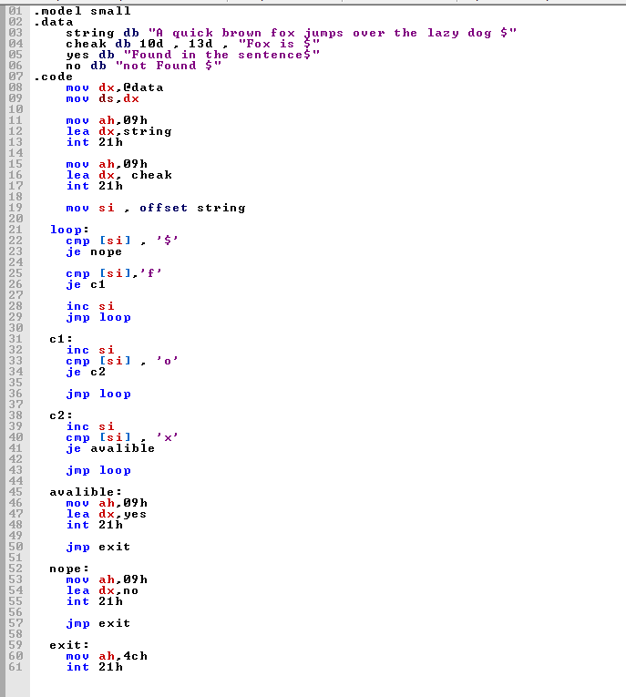

**Output**

